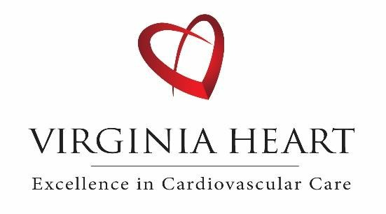

**PET Myocardial Perfusion**

**Stress Test**

**Patient Instructions**

A PET Myocardial Perfusion Stress Test evaluates how well blood flows through the heart at rest and during stress, as well as how effective it is pumping. To ensure the highest quality of testing, all instructions MUST be followed below. Please note: Patients who arrive unprepared for their appointment may be subject to a cancellation fee, as the study cannot be performed without proper preparation.

**Locations:**

Virginia Heart Cardiovascular PET/CT   
19450 Deerfield Avenue Suite 110   
Leesburg, VA 20176  
  
Phone: 703-226-1793  
Fax: 703-650-9364  
Hours: 7:15am-4:00pm  
  
(Park towards the back of the building. Upon entering, the *Cardiac PET/CT* suite will be on the right.)

Virginia Heart Cardiovascular PET/CT

2901 Telestar Court Suite 100

Falls Church, VA 22042

Phone: 703-226-1793

Fax: 703-766-5928

Hours: 7:15 am-4:00pm  
  
(From the main building lobby, walk straight past the elevators. Suite door is labelled *Cardiac PET/CT*.)

**Preparation:**

**Arrival & Timing**

* Your **appointment time is the scan start time — NOT your arrival time.**
* You must arrive at least **20 minutes prior** to your scheduled appointment for check-in and preparation.
* Plan to be in the office for about 45 minutes total (the actual test takes 30 minutes).
* Late arrivals may result in cancellation or rescheduling.
* **Important:** Virginia Heart has multiple Cardiac PET locations. Please double-check your appointment confirmation to ensure you go to the correct location.

**Cancellation Policy**

* Please call at least **48 hours in advance** if you need to cancel or reschedule your appointment.
* Appointments canceled with less than 48 hours’ notice may be subject to a cancellation fee.
* Patients who **fail to arrive 20 minutes before their scheduled appointment time** or who arrive **unprepared** may also be subject to a cancellation fee, as the test cannot be performed.

**Food & Drink**

**⚠️ VERY IMPORTANT – CAFFEINE RESTRICTION ⚠️**

You must avoid **all caffeine and decaf products for at least *24 hours* before your test.**

This includes:

* Coffee (regular **and** decaf)
* Tea (regular **and** decaf)
* Soda
* Chocolate
* Energy drinks
* Medications such as Excedrin, Fioricet

❌ *If you consume caffeine or decaf within 24 hours of your appointment, your test cannot be performed and will need to be rescheduled.*

* **No food** **4 hours** before your test.
* **Drink water** to stay well hydrated.
* **No alcohol** for **24 hours** before your test.

**Clothing**

* Wear loose comfortable clothing.
* Avoid one-piece outfits. A button-up or top with plastic zipper is preferred. No metal buttons, zipper, snaps, etc.
* **Women:** Avoid underwire bras (sports bras without metal clips are fine).

**Other**

* No tobacco or nicotine products for **12 hours** before test.
* No lotions or oils on chest the day of test.

**Medication Instructions:**

***\*\*\*Important: For any questions regarding holding the medications listed below, please consult with***

***your physician. \*\*\****

* **Stop 48 hours before:** Persantine, Dipyridamole, Theodur, Theophylline, Aggrenox, Trental.
* **Stop 24 hours before:**
  + Nitrates (Imdur, Isosorbide, Isordil, Nitroglycerin, Nitrostat).
  + PDE-5 inhibitors (Viagra, Cialis, Levitra, Stendra).
  + Herbal supplements & stimulants (Adderall, Vyvanse, methylphenidate, dextroamphetamine).
* **Diabetes medications:**
  + Skip your morning insulin or diabetes meds.
  + Bring medication + light snack to take after test.
  + Insulin pump or long-acting insulin → consult prescribing provider.
* **COPD/asthma:** Bring inhaler with you.
* **All other meds:** Take as normal.

**What to Expect:**

1. An IV will be placed in a vein to inject Rb-82, a radioactive tracer, to evaluate the blood flow to your heart. You will then be escorted to the scanner and lie on your back on the imaging table with arms above your head during scanning. You will be on the imaging table for the entire duration of the exam. Support rests for your head, arms, and legs will be provided to ensure that you are comfortable.
2. A low dose CT scan will be performed immediately followed by a PET emission scan of your heart. These images will be performed twice, the first set of images will be acquired before your stress test and the last set of images will be acquired after your stress test.
3. During the stress test portion of your study, Regadenoson will be infused to simulate the effects of exercise and increase the blood flow to your heart. The clinical team will go over the possible and common side effects that you may experience.
4. Your PET/CT study will be dictated and finalized within 2-3 business days. Results will be sent to your referring provider. You may view your results in MyChart within 2-3 business days from the study date. The camera often picks up areas beyond the heart, so you may also receive a second report from our Radiology partners for the non-cardiac imaging. You will not be charged additionally for this report.

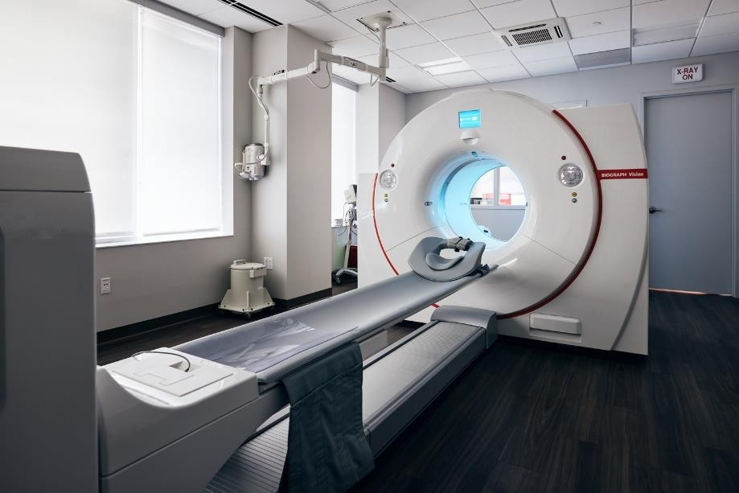

***As required by Section 6003 of the Patient Protection and Affordable Care Act, the following is a list of suppliers that also provide Cardiac PET imaging services within a 25-mile radius of this location:

1. Woodburn Nuclear Medicine, LTD – Metro Region PET Center, LLC

3289 Woodburn Road Suite 60 Annandale, VA 22003

1. Capitol Cardiology Associates 5801 Allentown Rd., 406

Camp Springs, MD 20746

1. Carient Heart and Vascular PC Manassas

8100 Ashton Avenue Suite 200 Manassas, VA 20109